POLITICAL SYSTEMS AND A CONTINUING ACCOUNT FOR ELUSIVE PEACE IN REPUBLIC OF MACEDONIA

Hyreme Gurra
State University of Tetova
Faculty of Philology
Department of English Languague and Literature
Email address: hyreme.gurra@unite.edu.mk

Article Info |  | ABSTRACT
Article history:  Received: mm, dd, yyyy  Revised: mm, dd, yyyy  Accepted: mm, dd, yyyy |  | This research paper is going to elaborate the five most common political systems of the world and the second part of the mainstream headlines preoccupying the public opinion which continued the saga for entire inhabitants of Republic of Macedonia. The country is internationally known as FYROM, and its government as a whole the recent days after New Year’s Holidays of 2018 was expecting an act of resignation by the Prime Minister Nikolla Gruevski and a massive unrest took place by NGO asking to close factories polluting the air. The leading political parties of the government consisting of VMRO (IMRO) (ethnic Macedonian political party) and BDI (DUI) (ethnic Albanian political party) were in the verge of a complete breakdown. These two coalition members were accused by the opposition political party LSDM (SDUM) ( left party) for a great number of scandals; corruption, leading autocratic zests policy, not enjoying EU and NATO, spending public money in non productive means and finally the phone tapping become sources of constant conflict. Social dialogue between the position and opposition was undermined by the head of the government, considered as a roguishly human hobble. The deterioration of the already unfavorable international position of the country endangered the progress leading up to national an interethnic cleansing. These events eventually would shape the future of the state. After the elections the government changed the leading stream which is see as a last chance for survival. The research methods being used throughout this paper are; the method of interview, narrative method, qualitative and quantitative method.
Keywords:
Deterioration, ethnic crisis, Theocracy, Despotism, Ochloracy, Gerontocracy.

Introduction
Speaking of political systems, it is difficult to figure out the frames of two identical ruling principals in two countries claiming to use one of five most common political systems of the world. Each state uses its own variant of Democracy; Republicanism; Monarchy; Communism or Dictatorship. These political systems derived from ancient ruling orders of social classes such as; Authoritarianism; Totalitarianism; Theocracy; Despotism; Ochloracy; Gerontocracy; Integralism; Khanate; Unitary authority; Facism; Federalism; Superstate; Electocracy; Corporatism etc.
Understanding different political systems is more than necessary. Every political system has its advantages and disadvantages. When being elected by people is worth considering the merits of each system an incorporating the most appropriate forms of ruling for the benefit of citizens, human kind in general.

Republic of Macedonia has chosen the system of Republicanism. So far is this country running the appropriate system?
What would Percy Byce Shelly add to his famous poetry “THE MASK OF ANARCHY” if alive to this very century?
“And he wore a kingly crown;
And in his grasp a scepter shone;
On his brow this mark I saw—
‘I AM GOD, AND KING, AND LAW!’”
The Mask of Anarchy; (Shelley, 2014)
And what would Mahatma Gandy recommend for a peaceful revolution in spite of Waterloo or Peterloo Massacre taking place in St Peter’s field, Manchester, on 16 August 1819, by people who enhanced the appeal for political radicalism for parliamentary reform.
The real narrative of the Government of Republic of Macedonia personified Corruption, Murder, Fraud, Hypocrisy, Destructions, and Anarchy is out of reality. The citizens felt and feel outrageous as far as the foreign community; exactly Brussels remained indifferent toward the government’s autocratic attitude against all except the believers of VMRO platform. According to the assembled information it is revealed that the monopolistic-monoethnic rule of the country was conducted by the Nikola Gruevski, who was the key to the Supreme Court, the key to the President of the State, the key to the Army, the key to the Military Forces, Foreign Affairs, Judiciary, and Parliament. The government was ruling in political autism.
Continuous disputes are considered multi dimensional and the last one was considered first of this kind. There is no record found that an inter nation conflict registered in since 1945. All the conflicts were conducted between Albanians and Macedonians. Certain warnings were displayed threw media, in case inner ethnic or religious conflict is cast, citizens should be indifferent of any planned scenario of an imposed conflicts to drag away the attention from the real situation.
The tipping point of the entire process is that Gruevski-s Cabinet lost the credibility. The leaking of the information from the Ministry of Interior means that the security of the state was ruined. The first minister to be targeted was Gordana Jankullovska, the head of order and the security of the state. She couldn’t manage the institutions properly and prevent her own wiretapping. What could one think of the entire security of the country as a whole? The fact still remains enigmatic, that the responsible ministers didn’t obstinate or resign. ‘A modus Vivendi’ act was to be elaborated. After the elections the nominated members of VMRO signed a document in case they resign beforehand were obliged to pay a penalty of 400 000 € to the budget of VMRO. So far as the process was going on, the two major accounts are felt with immense revenge and the situation was tense.
A dose of unrest was seen among the students. Their revolt was based on the recent changes of articles which undermine the rights of the students. The students Plenum appeared inclusive. They managed to break the stereotype barriers protesting on ethnic bases.
For the first time in the history of the country journalists and students of different ethnicities protested together. It was seen as a ray of the future since the de-legitimization of the government and institutions were seen as a hard process. The citizens lost their faith and the moment in the scene appears a multi ethnic society based on the principles of “Paris Commune” it demonstrates the values of building independent institutions. Youth’s vision is enthusiastic and avant-garde.
If it is seen in retrospective the backgrounds of all political parties, there is to conclude that SDSM’ policy of the conflict period of 2001, drastically differs from the SDSM initiating today’s tensions. In the meantime there is a great difference between VMRO of 2001 and the VMRO of today. Whereas, considering the Albanian Opposition Parties, they play the role of the deaf-mute. While the radical DUI of 2001 conflict, responsible for the advancement of basic human rights of Albanians guaranteed by international laws, is more interested in economical adventsments rather than political.
Zaev was not publishing all the “bombs” especially they target the Albanian. Once with them tends to ensnare the Albanian officials. When asked, he claimed not to lower their publicity. Zaev should apologize Albanians when they were in power did not implement the Albanian demands.
Collected the Albanian taxes and never invested in the cities where the majority of the population is Albanian. Even the names of the streets are to be called by the Former Yugoslav terms. The principle of Badinter is the only obstacle.
Gruevski was avoiding “Habeas Corpus” and continued with faults. After the heard discussion containing threat, corruption, offences, deadfalls, bribes, counterfeiting, coarseness, organized crime none of the ministers apologized or resigned. The allegations should be taken seriously. There was a call for responsibility. The remedy needed to be provided by technical and political support.

The final steps towards solid solution were as follows:

1. VMRO Party must democratize.
2. The government should have resigned.
3. A technical government should have been composed.
4. Independent Judiciary.
5. International monitoring.

The State should have been run by a technical government. The law should not require political approval for the appointment of new set of judges. The National broadcasting company MIA should have been run by independent journalist.

The future processes should be monitored by Foreign monitoring especially Washington and Brussels. New Election Commission needed to establish strict criteria determining the voters’ eligibility. Specific written instructions stressing that voting should always be democratic. Illegal approach would make the electoral boards more aware of the issue and would prevent such a practice in future elections.

Additional measures should be taken to deter violations of procedures by election officials and to punish those responsible for irregularities. The time of solving the case should be short and limited. The government should continue the path towards NATO and EU integration.
Fair Elections a Crucial Key to Solution

“Macedonia Risked Opposition Boycott over Early Polls. Ruling parties have unilaterally decided to press on with early elections in April, despite opposition insistence that conditions for fair and free polls were not in place.”(Marusic, 2016; News)
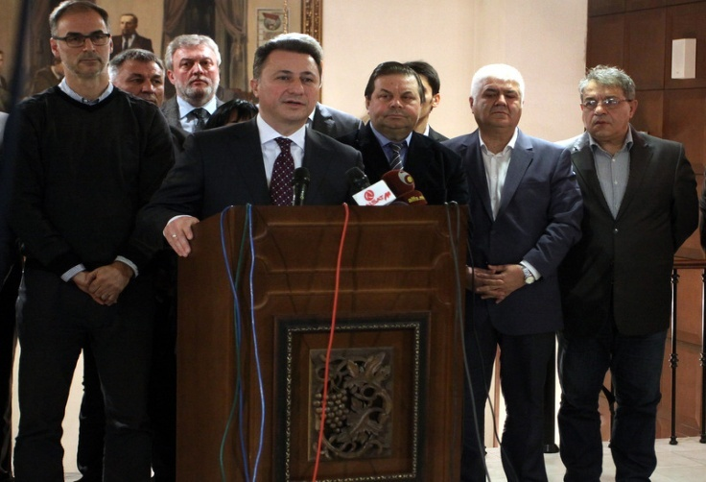

Macedonian Prime Minister Nikola Gruevski confirmed on Monday that he wants to go ahead with early elections on April 24, 2016, Photo by: MIA

A call for voting and verifying the resignation of the ruling Prime Minister Nikola Gruevski, voted to dissolve parliament and elected a new government, paving the way for elections on 24 April 2016. The Parliament was short of MPs from the main opposition party, the Social Democrats, and 72 out of the 123 deputies voted to dissolve parliament, 60 days before the elections, so that the early general polls can take place on April 24. Due to acceptance of the resignation of Prime Minister Gruevski, President Gjorge Ivanov handed the mandate to form a new interim government to Emil Dimitriev, the secretary-general of Gruevski's VMRO DPMNE party.
The new government authority at the helm was elected by 72 votes which will be in charge until the elections agreed. The unilateral move by the ruling parties came after the Social Democrats said they would boycott the polls unless key obstacles are avoided for fair elections as stipulated by the EU-Perzhino political accord aimed at ending the country’s long-running crisis. Ilija Dimovski, an MP from the VMRO DPMNE party, told parliament, however, that it was “time for citizens to take charge” of the political process. “The dissolution of parliament is the highest moral gesture,” Dimovski said. Liljana Dimovska, an MP who heads the small opposition Democratic Renewal party, warned that the unilateral decision to set the election date without opposition agreement was a recipe for more political chaos.“This is an introduction to a new destabilization of Macedonia.
Elections without the opposition parties would have lead to a boycott and countless street protests. In its first reaction to the decision to press ahead towards elections without cross-party agreement, the opposition said in a statement that the move only proves that “Gruevski is afraid and runs away from free, fair and democratic elections”. The opposition party recommended that they would not agree to polls in April unless the electoral roll was controlled properly for removing fake voters and media freedom was ensured in the country. The Social Democrat leader Zoran Zaev insisted that most reforms agreed in the agreement brokered by the EU representatives to end Macedonia’s political crisis have not been fully implemented or have only formally been addressed, although the deadlines for conviction has long time ago passed and that Gruevski should highlight his apostasy.

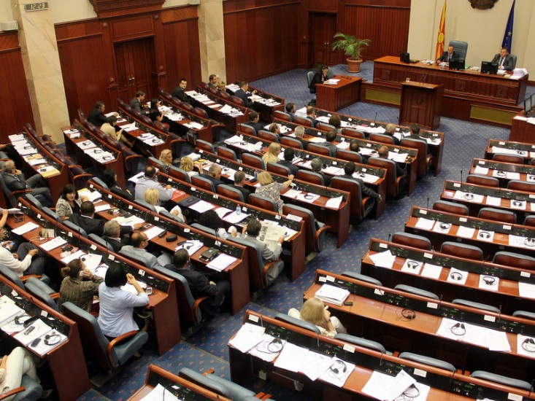

Macedonian parliament | Photo by: MIA

EU Must Oppose April Elections in Macedonia

There was a general opinion that the decision to press on with early polls, against all expert advice, proved that the government had no interest in a fair vote said Erwan Fouere. The decision by the Macedonian parliament on the eve of Orthodox Epiphany to accept the resignation of Prime Minister Nikola Gruevski and call for the dissolution of parliament in preparation for early elections in April marks a further escalation in the crisis that has gripped the country. This decision was taken despite the advice of independent electoral experts, 70 civil society organizations and the State Electoral Commission that not all the necessary reforms to ensure an election free from the irregularities of the past would be in place by April. This is particularly the case with regard to the long-awaited vetting of the voters’ list.
The Parliament voted the decision just three days after the casual visit of Commissioner Johannes Hahn, accompanied by a delegation from the European Parliament, negotiated the June-July political agreement of the previous year. This agreement was aimed at restoring the rule of law in Macedonia, following serious allegations of criminal activities and abuse of power based on legislative and executive institutions led by senior members of the government and ruling VMRO-DPMNE party officials. This dramatic turn of events is clearly a failure for European Union diplomacy and again shows a lack of appreciation by the European Commission of the depth of the political and social crisis in Macedonia. It also makes the patient efforts of the EU facilitator Peter Van Houtte to foster consensus talks between all the political parties all the more complicated divergent and stubbornly difficult.

Agreement between the four political parties 20 July 2016
As the forced agreement was signed, on 20 July 2016 the four major political parties of Macedonia agreed on the following issues:
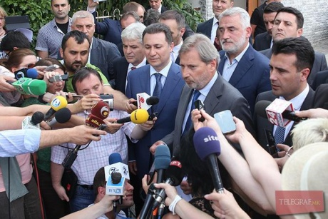

Voters list
1. The electoral code was to be amended by 22 July to reflect the agreement below on the voter list.
2. As regards annex A prepared by SEC relating to cross checks of entries, 171 500 persons will be placed on the supplementary part of the voters list and their right to vote is not disputed.
3. As regards Annex B prepared by SEC relating to cross checks of entries, 39 502 persons will be published by SEC within 3 days following the adoption of the amendment of the electoral code.
The second surreptitious violated concern was the Media Under this immediate consideration was agreed on:
1. The AVMS law and the electoral code was to be amended within 15 days from the date of this agreement.
2. AAVM will establish an ad hoc body to monitor compliance with media provisions of the electoral code. This ad hoc body will function until the end of the electoral process. This ad hoc body shall be established within 30 days from the date of this agreement.
3. The four political parties committed to amend the media legislation in line with Urgent Reform Priorities and the Priebe report within 6 months after the elections were made.
4. In consultation with the other parties, the biggest opposition party will nominate a chief editor (information agency) of the Public Broadcaster (MRTV) from experts in the field. Provided that the parties confirm that the conditions for elections are in place, the new chief editor will assume his / her functions within 100 days before elections take place.
5. Legal changes will be made to allow 7/24 Albanian channel on MRTV.
Next step is going to be the assessment of progress

By 31 August, leaders of the four political parties would be observing whether the above mentioned criteria have been ensured by which the conditions for holding free and responsible elections are fulfilled. The leaders would meet in due time to ensure the efficiency of the process and confirm the date of elections by a procedure of singeing a signature.
Following the Przino recommendations, if elections take place during 2016, a new government agreement will be voted in by the parliament within 100 days before the agreed day of Parliamentarian elections.

The following immediate thing to support is the Special Prosecution

a) In case Constitutional Court decides SP legislation or its part is unconstitutional, four parties commit to align the legislation with the decision of the Court and to re-establish the office according to decision within five days. The effectiveness, scope and objectives of the SP should be maintained.
b) Four parties call on the Constitutional Court to decide on SP law as soon as possible on the next possible session.

The final part of this agreement was the Reforms

The entire the process of well adjusted reforms and their inclusive implementation was to be led and conducted by a working group of the parliament including civil society and internal and external experts.
a. Prioritized adoption of Urgent Reform Priorities and Priebe Recommendations.
b. Amend whistleblower law according to Venice Commission within 6 months.
c. OFA
d. Euro-Atlantic integration.
The tense environment led some of the leaders to express their concern through the discourse of sensibility and sympathy and ask the foreign community that Grueski should highlight his apostasy from radical politician

Macedonia was heading towards “Deepening crisis”!
After rounds of hours of talks within months of time with EU intermediates the four leaders of political parties in the country have not dropped a deal to implement the agreement of 2 June. The media revealed statements of heads of political parties, the disappointment of Commissioner Johannes Hahn, and Menduh Thaiçi’s rejections to the statement of the media. SDSM fiercly denied that they will not take part in the elections, as the country estimates are not eligible for the holding of democratic elections. Zaev told a short statement to reporters:"For us, elections are not acceptable. Without being arranged in time, and cleaning of the electoral list, we do not take part in the elections. We will continue, for fair and democratic elections." DUI's leader Ali Ahmeti, after the meeting said that the negotiating parties had differences and have not advanced to agree on election date. According to Prime Minister Nikola Gruevski, leader of SDSM's Zoran Zaev was seeking delay of the election after bone aware of the profound loss of host’s. After the meeting, spoke to the media bone Commissioner Johannes Hahn.
"The European future of Macedonia depends on agreement of Przino". Ambassador Willem Wouter Plomp Dutch presidency stressed that Macedonia will work on full implementation of the Agreement Pzino. Within the chairmanship Dutch European Union (EU) for the period January to June 2016, at the session of the National Council for Integration in the Macedonian Parliament, the Dutch ambassador in the country, Willem Wouter Plomp, presented the program and priorities for the work of the presidency of the Netherlands EU, reports Anadolu Agency (AA).Wouter Willem Plomp Ambassador stated that the Dutch presidency's priorities during this period are comprehensive approach to the problem of migration, the European commitment to a healthy financial system, as well as climate change and energy issues. He stressed that the Dutch presidency will work in the crisis of immigration, good ethnic relations, and full implementation of the political agreement or the so-called "Përzhino’s Agreement". "For the first time since the fall of Communism, the EU is facing a situation in which the prime minister of an EU candidate country must abdicate because of indications for criminal and political wrongdoings," Nano Ruzin, former Macedonian ambassador in Brussels told DW. An EU expert’s report in June noted various forms of government corruption, such as electoral fraud, blackmail and extortion. It also highlighted "an unhealthy relationship" between top governmental officials and the media.
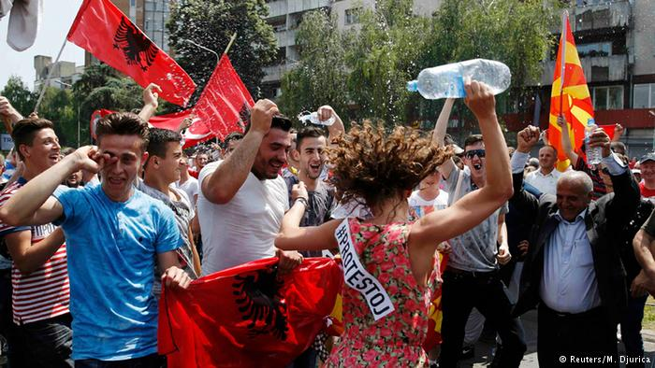

The tense atmosphere and generally incapable of being controlled the rebelled mass followed the trajectory of the governmental establishment being libeled for corruption allegations and the opposition party inflaming the turbulent temper. Eager for revealing the surreptitious tapping dews thousands of people in the streets of the cities of Republic of Macedonia. “But according to three members of the European parliament, Ivo Vajgl, Richard Howitt and Eduard Kukan who visited Macedonia on Tuesday, the agreement is still far from being fully implemented, despite the country's steps toward restoring parliamentary stability and investigating the corruption allegations”.

Conclusion

Due to international pressure based on the main conditions of the Agreement, on 1 st September, 2016 the opposition party SDS was back in the Parliament, with a list of new ministers members of the cabinet of the government such as; Interior Minister Oliver Spasovski, and Minister of Labor and Social Policy Frosina Remenski, as well as the alternate ministers. The immediate request of the opposition - Nikola Gruevski's resignation - was also performed. The visiting members of foreign community in Macedonia stated that the implementation of the agreed reforms and the fair elections would be considered key conditions for the country's future in the EU. Otherwise Macedonia might become the first country to lose the EU recommendation to open accession negotiations. The swaying policy of Gruevski asking for allies in East and his corruptive stubborn autocratic policy lead three mandates, hoarsened citizen’s social welfare state and brought the country to the brick of civil war, perpetuate the crisis and legitimize the farewell to democracy in the country . The latest polls performed by different institutions come up with results that suggested that Gruevski and his nationalist-conservative party are big favorites at some extend to win the elections if they take place. Some analysts shared the concern that this sort of result might cost Macedonia not only its EU and NATO candidate status, but the most precious the act of democracy itself.

While the narrator of this research paper - an expert of International Justice and foreign Affairs shares the opinion that the current situation makes the European Union equally responsible for the future of the country and she is fully convinced that that Gruevski would be ready to risk Macedonia's EU integration to rule the country for another term.

Bibliography
- Shelley, Percy Bysshe, 2014, The Macs of Anarchy-a poem, Read Books Limited.
News
- Sinisa Jakov Marusic, 2016, “ News” 19 January,2016
- Bota Sot 25 November 2015
- Top Channel 15 January 2016
- A1 On Mk 16 January 2016
- Bota Sot 25 November 2015
- Stratfor Media Center 31st December 2015
- Erwan Fuere BIRN Ohrid 21 January 2016

References

- http://www.independent.mk/articles/32633/Year+Later+What+is+Left+of+Przino+Agreement( accessed on 04/08/2016)
- http://eeas.europa.eu/archives/delegations/the_former_yugoslav_republic_of_macedonia/press_corner/all_news/news/2016/2016-07-20_agreement_en.htm (accessed on22/01/2017)
- http://ec.europa.eu/enlargement/news_corner/news/_files/20150619_recommendations_the_seniorexperts_group.pdf. (accessed on 08/07/02016)
- http://www.dw.com/en/eu-hols-key-to macedonia-political-crisis/a18980323 (accessed on 07/09/2017)

Sinisa Jakov Marusic Balkan Insight 19 January 2016
Erwan Fuere BIRN Ohrid 21 January 2016
http://eeas.europa.eu/archives/delegations/the_former_yugoslav_republic_of_macedonia/press_corner/all_news/news/2016/2016-07-20_agreement_en.htm (accessed on 22/01/2017)
http://eeas.europa.eu/archives/delegations/the_former_yugoslav_republic_of_macedonia/press_corner/all_news/news/2016/2016-07-20_agreement_en.htm (accessed on22/01/2017)
Ibid
Ibid
A1 On Mk 16 January 2016
http://ec.europa.eu/enlargement/news_corner/news/_files/20150619_recommendations_the_seniorexperts_group.pdf. (accessed on 08/07/02016)
http://www.dw.com/en/eu-hols-key-to macedonia-political-crisis/a18980323 (accessed on 07/09/2017)

